Project: Pizza Place Sales

1. Executive Summary

This report provides an analysis of the sales performance of Eat All pizza place for past year. It identifies the top-selling and low preforming pizza, peak sales period and promotional opportunities. Based on the data, recommendations are provided to optimize the menu and improve sales.

1. Introduction

The pizza restaurant wants to optimize the menu by leveraging data. This analysis aims to answer key business questions:

1. How many customers do we have each day? Are there any peak hours?
2. How many pizzas are typically in an order? Do we have any bestseller?
3. How many money did we make this year? Can you identify any seasonality in the sale?
4. Are there any pizzas we should take off the menu, or any promotion we can leverage?
5. Data Collection and Preparation

This data obtained from maven analytics site which provides open datasets. The data contains the following key tables:

* Orders: order date and times
* Order details: details of each transition
* Pizzas: price and size
* Pizza types: type of pizza and ingredient

1. SQL Queries and Analysis

* How many customers do we have each day? Are there any peak hours?

To find the customers we have each day and the peak hours:

* The busiest day was Friday, indicating peak weekend traffics
* The slowest day was Sunday

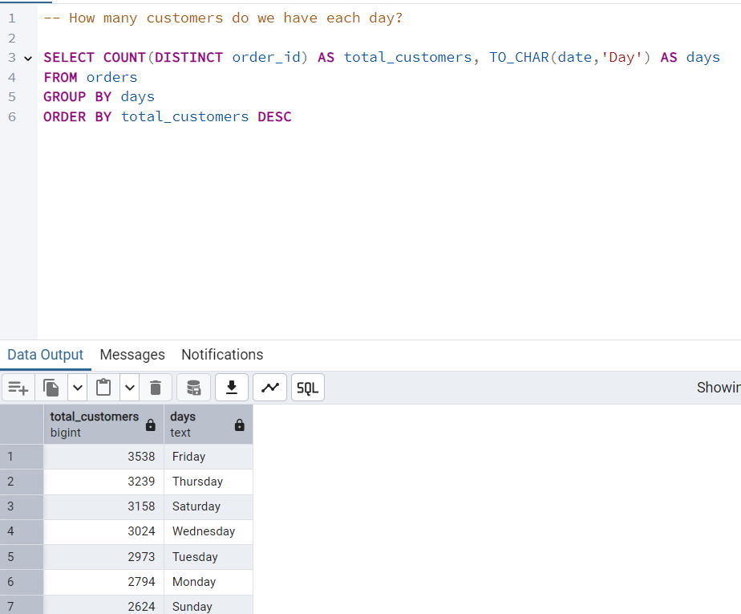

Peak hours:

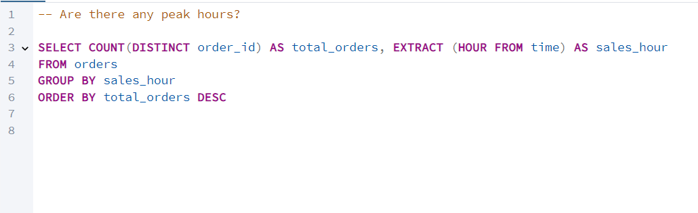

Peak hours are (12 PM – 9 PM)

* How many pizzas are typically in an order? Do we have any bestseller?

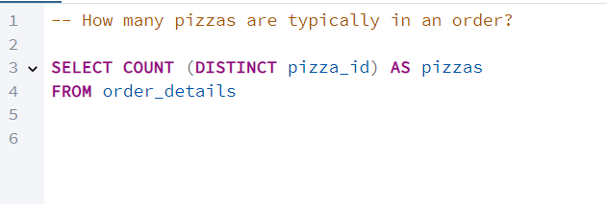

* There are 91 pizzas in an order.
* Best Selling Pizzas:

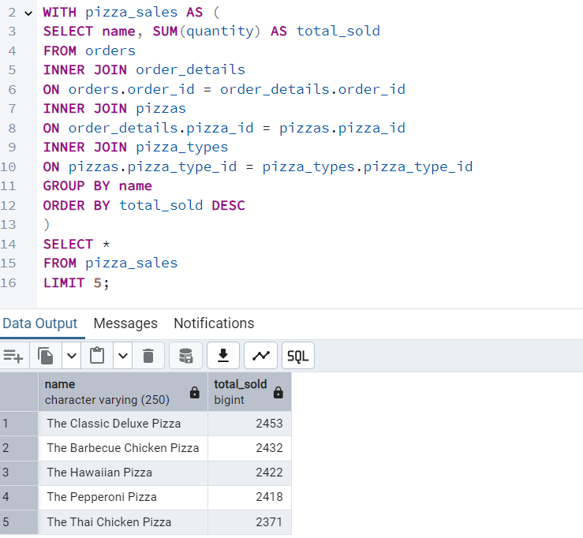

* How many money did we make this year? Can you identify any seasonality in the sale?

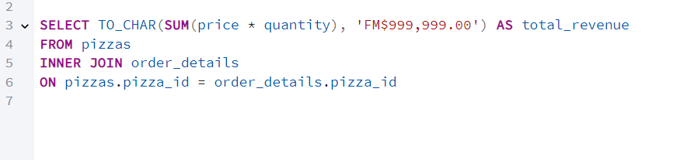

* The total revenue generated from pizza sales this year is **$817,860**.

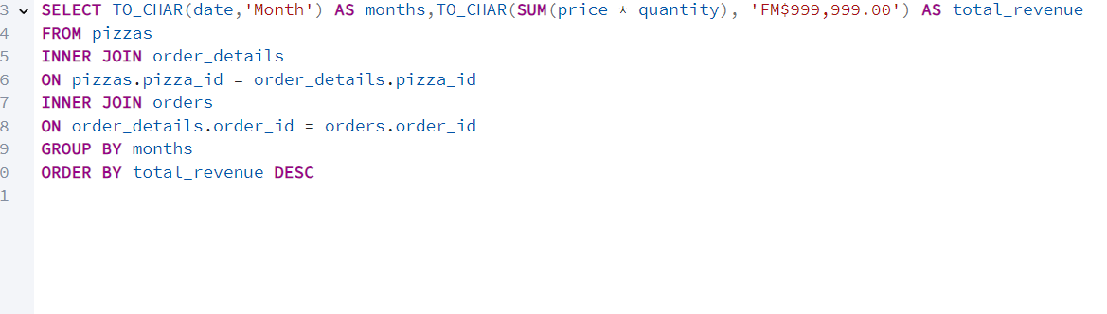

* The highest sales occurred in July (**$72,552.9**), indicating strong demand during summer.
* The lowest sales occurred in October (**$64,027.6**).
* Weekly sales patterns
* Friday to Saturday had the highest sales, likely due to weekend dining
* Sunday and Monday had the lowest sales
* Are there any pizzas we should take off the menu, or any promotion we can leverage?

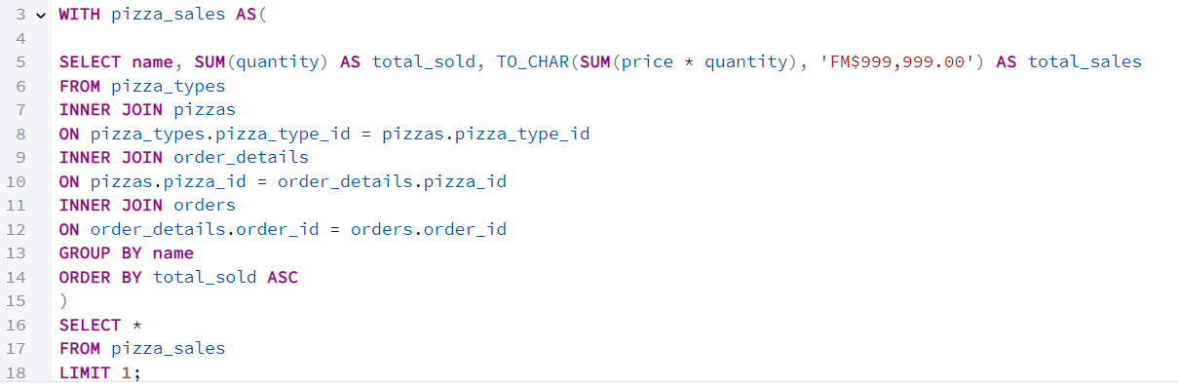

* The least ordered pizza: The Brie Carre Pizza (only 490 orders over year) due to poor marketing

1. Results and Insights

* Busiest day was Friday, and slowest day was Sunday
* Peak hours are lunch time (12 PM – 1 PM), and dinner time (6 PM – 9 PM) also the busiest
* Total revenue **$817,860.**
* the highest sales occurred in July, and the lowest October.
* The least ordered pizza: The Brie Carre Pizza.

1. Conclusion and Recommendation
2. **Increase Promotions on Fridays and Saturdays**:

* Since **Friday and Saturday** are the busiest days, consider running **special promotions** or **combo deals** to attract even more customers and maximize sales during these peak days.
* **Loyalty programs** or **happy hour discounts** could be effective in increasing sales during these high-traffic days.

1. **Leverage Peak Hours (12-1 PM and 6-9 PM)**:

* Focus marketing efforts on **lunch and dinner rushes** by offering targeted promotions during these hours.
* **Pre-order and delivery options** could be emphasized for customers who want to avoid long wait times during busy periods.
* Consider adding **"express lunch" specials** to cater to customers looking for quick service during the midday peak.

1. **Boost Sales During October**:

* **October’s low sales** could indicate a seasonal dip. Consider running a **fall promotion** or introducing **seasonal pizzas** to draw in more customers.
* Launch a **"Halloween Special"** or **“October Discount Week”** to encourage visits during this slower month.

1. **Reassess the Brie Carre Pizza**:

* Since the **Brie Carre pizza** is the least ordered, consider evaluating whether it's worth keeping on the menu.
* **Market Testing**: Gather feedback from customers on why this pizza is underperforming.
* **Modify the Recipe**: Adjust the toppings or reduce the price to make it more appealing.
* **Special Promotion**: Introduce a limited-time discount or feature it as part of a **"Gourmet Pizza Week"** to give it more visibility.
* If sales remain low despite efforts, consider **removing it** from the menu to make space for more popular items.

1. **Optimize Menu for Seasonal Preferences**:

* Since **July** had the highest sales, it’s clear that summer months lead to higher pizza demand.
* **Seasonal Menu Adjustments**: Offer lighter pizzas or summer-inspired options during the hotter months, while introducing **heartier or more comforting options** for fall and winter to cater to changing customer preferences.